**Build a Random Joke Generator with Character Count Feature**

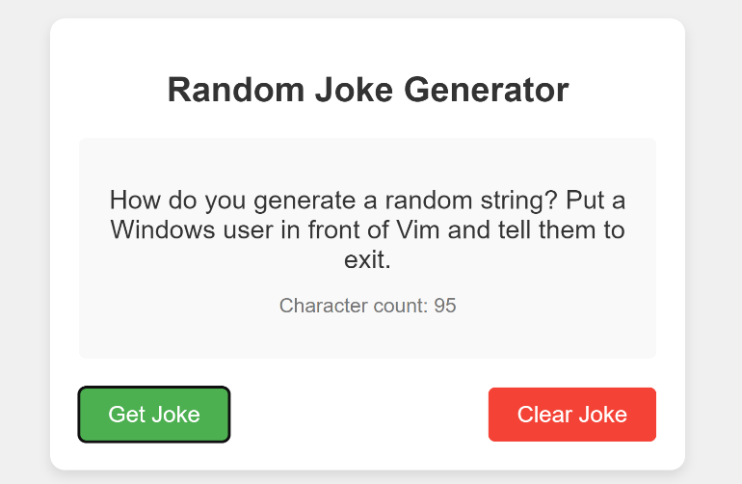**Expected Outcome:**

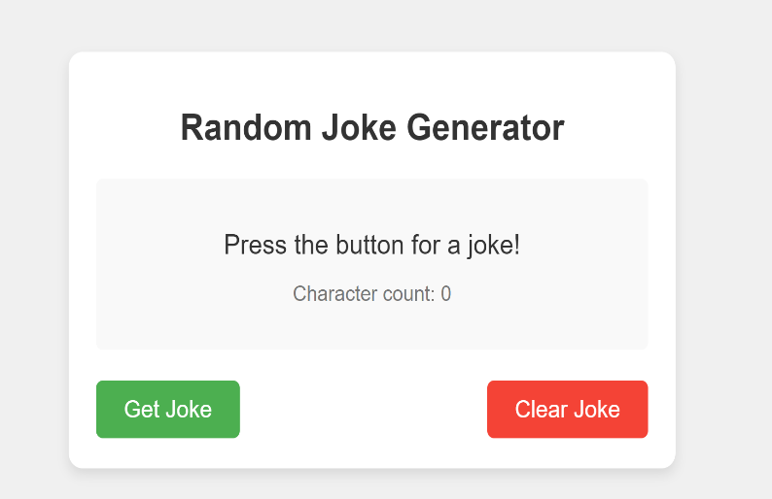

**Pointers to code the TEST Assignment:**

1. **Section A: [30 Marks]**

* Implement a joke generator using:

***API:*** [***https://v2.jokeapi.dev/joke/Any***](https://v2.jokeapi.dev/joke/Any)

* Display the joke in a dedicated area of your app.
* Implement a button labeled **"Get Joke"** that fetches and displays a new joke each time it's clicked.

1. **Section B: Character Count and Clear Feature: [20 Marks]**

* Display the character count of each joke fetched below the joke itself.
* Ensure the character count updates with every new joke.
* create a "Clear Joke" button that clears the joke text and resets the character count.

1. **Section C: Error: [10 Marks]**

* Ensure error handling is implemented if the joke API call fails.

1. **Section D: CSS: [20 Marks]**

* Style the app as you wish to make it visually appealing!

1. **Submission Guidelines: [20 marks]**

* Upload your output in Microsoft Form.
* Submit your code in a GitHub repository [Create a separate folder]